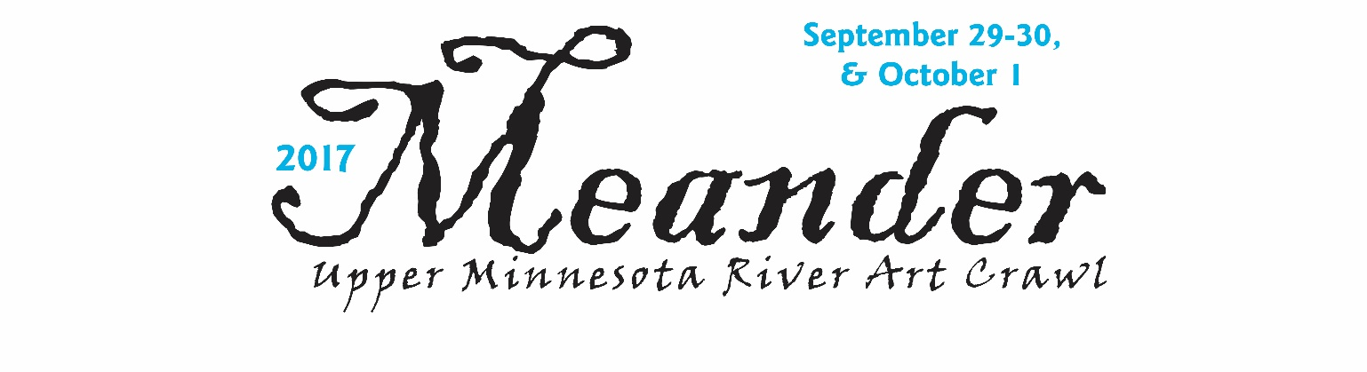
2017 Meander Economic Impacts

$111,920 Total reported Meander art sales to customers during the Meander weekend.
(39 surveys reported)
2016 reported $114,726 with 43 surveys returned

$2,870 Average reported art sales per artist. ($2,668 in 2016)

60% Money raised to organize the Meander through sponsors and artists was spent on products or services (printing, paper, advertising, graphic design, staffing) in the five-county area. Meander spent nearly $8,000 on advertising in 2017; 27% of the total budget.

85-1500 Reported total number of customers at individual studios for the entire weekend.

11 studios Average number of studios customers visited. (12 in 2016)

3 people per travel party (on average)

75% of customers said the quality of the art was excellent (71% 2016)
77% of customers said their overall experience was excellent (83% 2016)

50% did NOT attend last year (50% in 2016)
73% plan to attend again next year (80% in 2016)
19% maybe plan to attend next year (17% in 2016)
33% first time to attend the Meander (28% in 2016)

45% came from within 5-county area (38% in 2016)
17% came from greater Minnesota (outside 5-county area) (30% in 2016)
25% came from the metro area (21% in 2016)
13% came from out of state (15% in 2016)

Average Expenditures per Customer

(354 reporting in 2017 vs 338 in 2016)
$124 on Meander Art ($110 in 2016)
$43 on Food/Gas ($36 in 2016)
$11 on Shopping, other than art ($12 in 2016)
$18 on Lodging ($17 in 2016)

Meander Upper Minnesota River Art Crawl • 320-289-1981 • www.artsmeander.com

