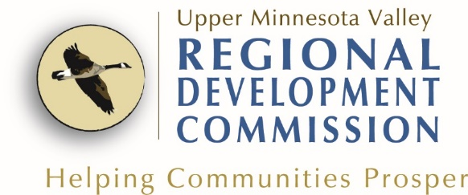
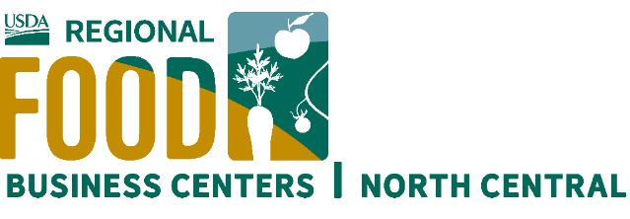

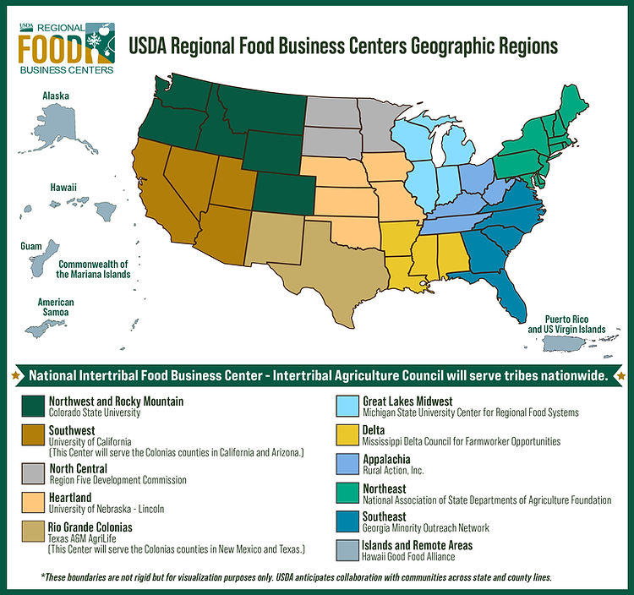
What is the North Central USDA Regional Food Business Center?

The USDA funded 12 Regional Food Business Centers that support all 50 U.S. States and Territories. The North Central USDA Regional Food Business Center covers Minnesota, North Dakota and South Dakota.

https://www.northcentralrfbc.org/

The North Central USDA Regional Food Business Center, also called the Center, is a collaboration of 35 partner organizations, helping to coordinate technical assistance and build capacity for farmers and food businesses in Minnesota, North Dakota, and South Dakota.

The goal of the Center is to transform a region that primarily focuses on commodity and large-scale agriculture into an area that also supports smaller, more resilient farm and food practices, specifically focusing on the development of critical infrastructure for small and mid-size livestock processing, fruit and vegetable processing, and warehouse space and storage operations.

UMVRDC Coordination
The Upper Minnesota Valley Regional Development Commission (UMVRDC) is one of the 35 partners for the Center and will provide technical assistance for our 5-county region (Big Stone, Chippewa, Lac qui Parle, Swift, and Yellow Medicine).
As a Regional Technical Assistance Provider, the UMVRDC will:
- Develop (& regularly update) a regional action plan that outlines and priorities to develop the local food system.
- Coordinate with other partners to identify and enhance the value chain/supply chain.
- Assist smaller-scale food producers and food and farm businesses in the middle of the supply chain in identifying and navigating third party financial assistance, particularly from federal, state, tribal, and other sources.
- Leverage funds by writing grants for local foods systems improvements.
The UMVRDC is a technical provider of the Center and can guide access to funding, including the Business Builder sub-award grants intended to provide food and farm businesses with up to $50,000 in capital needed to launch and expand their business. To learn more about this program, visit northcentralrfbc.org

Goals

Create a regionalized food system

Create economic benefits for growing local foods.

Upper Minnesota Valley Regional Development Commission

REGIONAL ACTION PLAN

North Central Regional Food Business Center
The purpose of our Action Plan is to identify needs and opportunities that support a regional food network throughout the UMVRDC five-county region. The Action Plan will direct resources over the next five years that are the result of the USDA funded NCRFBC grant award. www.umvrdc.org/local-foods/

Goals, Strategies and Actions for the UMVRDC Region

Identify key resources that can support community-led strategy and plan for advancing a community-based food system in Upper MN Valley Region.

Identify and connect growers and market partners.

Increase Marketing and Promotion.
- Our region has 1,758,305 farmable acres.

- Our five-county region has a population of 43,346 (2022 Population estimates)

- Agriculture is a key industry in our five-county region, with 3,526 farms producing just under $1.2 billion products (2017 Census of Agriculture)

Develop a larger Market for Local Foods.

Year 1: July 1, 2023 – June 30, 2024

- Coordinate with other partners on a regular basis to identify gaps and avoid duplication.
  - Focus Group meetings (coordinate with LSP)
  - Attend regional local food meetings.

- Complete the Action Plan
  - Research past Local Foods Initiatives
  - Collect Data and basic Local Foods Value Chain information.

- Review the Action plan and determine priorities, timeline, and project lead.
  - Research and connect with stakeholders.

- Leverage funds by writing grants for local foods systems improvements.
  - RSDP/ESMC grants to work on more items identified in the Action Plan
  - Create capacity to assist with Business Builder Subgrants
  - Research other grant opportunities.

