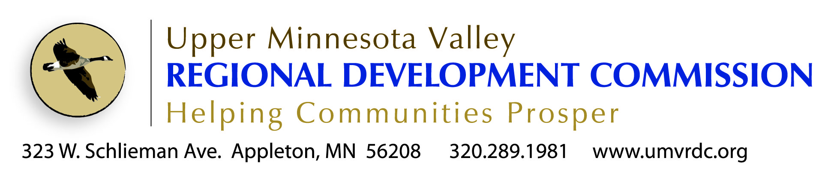

Planner Position Profile
Community/Economic Development

The Upper Minnesota Valley Regional Development Commission (UMVRDC) is looking for a experienced community development planner to develop and manage projects with cities, counties and other organizations in the five-county UMVRDC region of Big Stone, Swift, Lac qui Parle, Chippewa and Yellow Medicine Counties.

The UMVRDC works with local governments and regional partners to provide planning tools and assistance to enhance our region. Basic responsibilities include zoning administration and ordinance writing; regional planning; redevelopment planning; community vision and strategic planning; presentations and meeting facilitation; developing and nurturing clients; project management.
The Position
Primary responsibilities will be in community and economic development planning and will include working in the following areas:
- Completing the requirements of the U.S Department of Commerce Economic Development Administration (EDA) Planning Grant including:
  - develop and implement the Comprehensive Economic Development Strategy (CEDS);
  - coordinate and encourage local units of government to use federal, state and local programs to implement CEDS identified activities;
  - provide technical assistance and economic development for communities in Region 6W;
  - explore opportunities for telecommunications development, including infrastructure and incubator facilities in Region 6W;
  - provide reports to EDA as required/requested;
  - meet all EDA investment guidelines with planning grant activities;
  - identify, encourage and support private sector and industry cluster development opportunities;
  - supply EDA with timely information on plant closures or prospective plan closings, as well as the number of employees affected by these actions.
Other work areas will be assigned and may include the following areas:
- Community strategic planning
- Capital improvement planning
- Environmental reviews
- Comprehensive planning and plan updates
- Zoning ordinance development
- Telecommunication/broadband planning
- MN DEED Small Cities Development Program grant writing and administration
- Hazard mitigation planning
- Renewable energy project development and grant writing

The position is available starting immediately.
Job offers are not final until receiving the UMVRDC Board of Commissioners approval.
What We Do
Our Mission: Enable the region to thrive through assisting local governments

In 1973 the Upper Minnesota Valley Regional Development Commission was organized by local elected officials as authorized by the MN Regional Development Act of 1969. Its purpose according to the legislation is:

“to facilitate inter-governmental cooperation and to ensure the harmonious coordination of state, federal, and local comprehensive planning and development programs for the solution of economic, social, physical, and governmental problems of the state and its citizens.”

The UMVRDC has professional planners that help units of government in our region get projects done. Through assistance with planning, grant writing and grant management, our staff is here to assist the public sector. We are experts when it comes to working with local, state and federal funding sources including grants, low interest loans and other assistance programs.

Our staff successfully secures financing for the following projects:
- Public Infrastructure (Transportation, Broadband, Water/Sewer/Wastewater)
- Downtown Revitalization
- Business Retention & Expansion (BRE) Efforts
- Industrial Development & Business Parks
- Hazard Mitigation Planning
- Parks, Trails & Other Outdoor Recreation
- Small Cities Development Community Development Block Grants used for:
  - Commercial Rehab
  - Homeowner Rehab
  - Rental Rehab
  - Community Facilities
  - Infrastructure

In Addition We Provide the Following Services:
- Grant Management (compliance with local, state & federal regulations)
- Planning (Community Development, Comprehensive Plans & Ordinances)
- Environmental Reviews
- Economic Development Marketing
- Website development

UMVRDC Core Values
“Core values and core purposes are essential for enduring greatness...build them into your organization & preserve over time” (Good to Great, Collins, 2001)
- Commission leadership
- Staff is accountable to and driven by the Board and the units of government in this region
- Leadership and assistance
- Agency’s role is to assist, guide, facilitate projects and programs for units of government in this region
- Integrity
- Respectful, open & transparent
- Progressive thought & action
- Moving forward, proactive and innovative
- Value all of our communities
- Quality service
- Striving for excellence in work and/or products
- Collaboration and cooperation
- To work together as a team toward a common cause
- Value the region’s lifestyle and all it has to offer
- Stewardship
- Pride in the agency’s abilities and capabilities
Who We Are

The Commission is a governing board made up of elected officials from counties, townships, cities, school districts and special interest groups.

Currently there are 7 full time staff.
- 1 Executive Director
- 1 Financial Officer
- 1 Accountant/Grants Manager
- 1 Senior Community Development Planners
- 1 Community Development/Transportation Planner
- 1Tourism Planner & Communications Specialist
- 1 Administrative Assistant

The new community development planner will work with and under the direction of other planners, and the executive director.

Office Environment
Staff travel frequently to meetings and events. Two agency vehicles are provided for their use.
Individual offices are provided with the exception of clerical staff.
Staff work individually and as part of a team of planners to develop and complete projects.
Flexible work hours and compensatory time when attending night meetings provide an accommodating work schedule.

How We Are Funded

The UMVRDC has local levy authority. Levy dollar are used for overhead, management costs of the agency and board, and match for projects and programs undertaken.

Staff are responsible for the development of contracts and grants to maintain the agency budget and staff positions.

Background & Experience
Related 4-year degree in community development, urban and regional planning, urban studies/design, or a related field. Experience in the previous fields preferred.
Night meetings and overnight travel is necessary.
Must have valid drivers license.
All finalists considered will be subject to a criminal background check.
Salary & Benefits
Starting salary $40,000+ depending on experience.
Benefits include full single health insurance high deductible plan ($3,000 single/$6,000 family maximum), 50% family coverage, full single dental, agency funded health reimbursement/savings account ($1,500 in 2013), life, flexible benefits plan, deferred compensation retirement savings plan, PERA.
Timing
The review of applications begins immediately. This position will remain open until filled.
To Apply
Send application, copies of college transcripts, and cover letter highlighting three things you can bring to the UMVRDC Community Development Team to:
Executive Director
323 West Schlieman Avenue
Appleton, MN 56208
    - dawn.hegland@umvrdc.org

Application and detailed job description online at www.umvrdc.org

