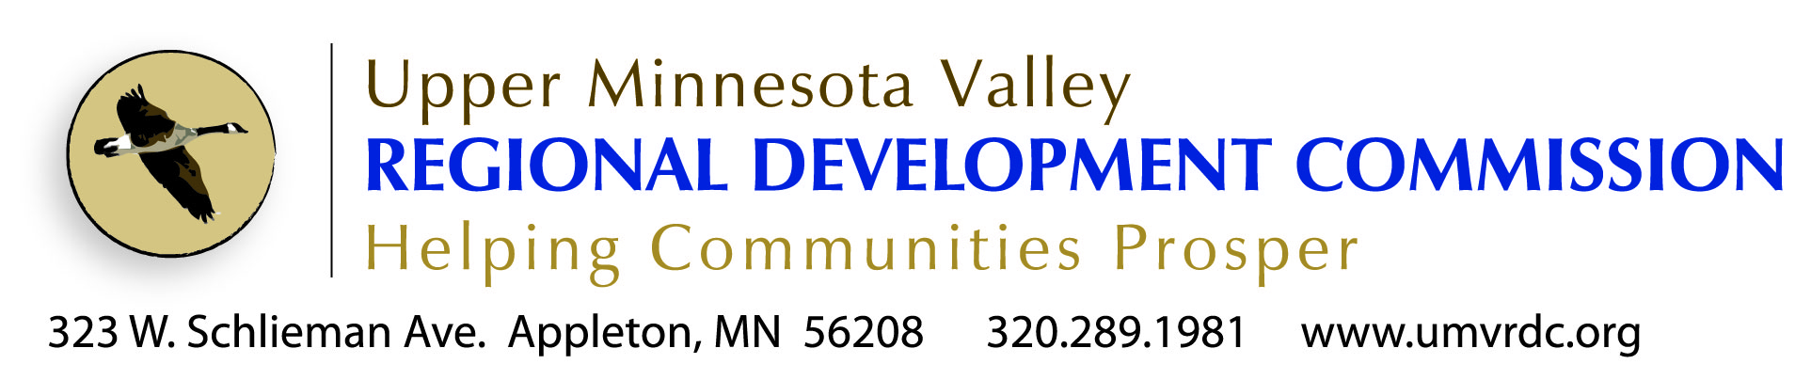

Assistant Finance Director
Position Profile
The Position
The Upper Minnesota Valley Regional Development Commission (UMVRDC) is looking for an experienced finance professional. This is a challenging position in well-established, quality organization. This position involves a strong working knowledge of accounting principles and procedures, A-133 audit preparation, compliance with state and federal grant conditions, financial reports and budgets, internal control procedures, payroll and accounts payable functions. Career growth opportunities exist.

The ideal candidate will display excellent communication, leadership and supervisory skills for this position. Candidates should demonstrate strong work ethic, excellent attention to detail, be well organized, have the ability to work independently on diverse projects and be a team player. Passion for customer service and for cultivating community relationships a must.
Application and full job description available at www.umvrdc.org
What We Do
Our Mission: Enable the region to thrive through assisting local governments

In 1973 the Upper Minnesota Valley Regional Development Commission was organized by local elected officials as authorized by the MN Regional Development Act of 1969. Its purpose according to the legislation is:

“to facilitate inter-governmental cooperation and to ensure the harmonious coordination of state, federal, and local comprehensive planning and development programs for the solution of economic, social, physical, and governmental problems of the state and its citizens.”

The UMVRDC has professional planners that help units of government in our region get projects done. Through assistance with planning, grant writing and grant management, our staff is here to assist the public sector. We are experts when it comes to working with local, state and federal funding sources including grants, low interest loans and other assistance programs.

Our staff successfully secures state and federal financing for the following projects:
- Public Infrastructure (Transportation, Broadband, Water/Sewer/Wastewater)
- Downtown Revitalization
- Business Retention & Expansion (BRE) Efforts
- Industrial Development & Business Parks
- Hazard Mitigation Planning
- Parks, Trails & Other Outdoor Recreation
- Small Cities Development Community Development Block Grants used for:
  - Commercial Rehab
  - Homeowner Rehab
  - Rental Rehab
  - Community Facilities
  - Infrastructure

In Addition We Provide the Following Services:
- Grant Management (compliance with local, state & federal regulations)
- Planning (Community Development, Comprehensive Plans & Ordinances)
- Environmental Reviews
- Economic Development Marketing
- Website development

UMVRDC Core Values
“Core values and core purposes are essential for enduring greatness...build them into your organization & preserve over time” (Good to Great, Collins, 2001)
- Commission leadership
- Staff is accountable to and driven by the Board and the units of government in this region
- Leadership and assistance
- Agency’s role is to assist, guide, facilitate projects and programs for units of government in this region
- Integrity
- Respectful, open & transparent
- Progressive thought & action
- Moving forward, proactive and innovative
- Value all of our communities
- Quality service
- Striving for excellence in work and/or products
- Collaboration and cooperation
- To work together as a team toward a common cause
- Value the region’s lifestyle and all it has to offer
- Stewardship
- Pride in the agency’s abilities and capabilities
Who We Are

The Commission is a governing board made up of elected officials from counties, townships, cities, school districts and special interest groups.

Currently there are 10 full time staff.
- 1 Executive Director
- 1 Financial Officer
- 1 Loan officer
- 2 Senior Community Development Planners
- 3 Community Development Planners
- 1Tourism Planner & Communications Specialist
- 1 Administrative Assistant

The new community development planner will work with and under the direction of other planners, and the executive director.

Office Environment
Staff travel frequently to meetings and events. Two agency vehicles are provided for their use.
Individual offices are provided with the exception of clerical staff.
Staff work individually and as part of a team of planners to develop and complete projects.
Flexible work hours and compensatory time when attending night meetings provide an accommodating work schedule.

How We Are Funded

The UMVRDC has local levy authority. Levy dollar are used for overhead, management costs of the agency and board, and match for projects and programs undertaken.

Staff are responsible for the development of contracts and grants to maintain the agency budget and staff positions.

Background & Experience
Candidates for this position must possess a degree in accounting, finance, business administration, public administration or a closely related field from an accredited four-year college or university and must have five (5) years related accounting or finance work. CPA certification a plus.
This position reports directly to the Finance Officer.
Night meetings and overnight travel is necessary.
Must have valid driver’s license.
All finalists considered will be subject to a criminal background check.

Salary & Benefits
Starting salary $53,000+ depending on experience.
Enjoy a professional, dynamic and creative culture, flexible work environment, exceptional benefits (Medical, Dental, Life Insurance, Flex Spending, employer funded HSA, Vacation, Sick, Paid Holidays, PERA and other retirement options.
Timing
The review of applications begins August 8 and every two weeks thereafter. This position will remain open until filled.
To Apply
Send application, copies of college transcripts, and cover letter highlighting three things you can bring to the UMVRDC Finance Team to:
Executive Director
323 West Schlieman Avenue
Appleton, MN 56208
    - dawn.hegland@umvrdc.org

Application and detailed job description online at www.umvrdc.org .EOE.

