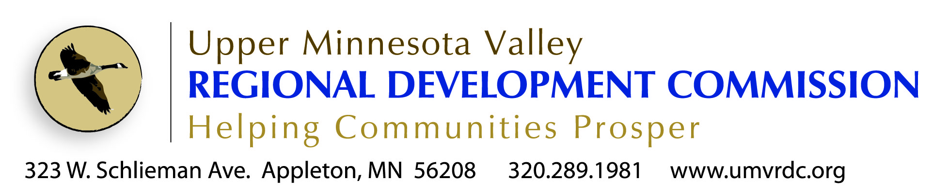

Loan Officer/Accounting Specialist
Position Profile

The Upper Minnesota Valley Regional Development Commission (UMVRDC) is looking for an employee to manage a federally funded business loan program in the five-county UMVRDC region of Big Stone, Swift, Lac qui Parle, Chippewa and Yellow Medicine Counties.

BACKGROUND
What We Do
Our Mission: Enable the region to thrive through assisting local governments

In 1973 the Upper Minnesota Valley Regional Development Commission was organized by local elected officials as authorized by the MN Regional Development Act of 1969. Its purpose according to the legislation is:
“to facilitate inter-governmental cooperation and to ensure the harmonious coordination of state, federal, and local comprehensive planning and development programs for the solution of economic, social, physical, and governmental problems of the state and its citizens.”

The UMVRDC has professional planners that help units of government in our region get projects done. Through assistance with planning, grant writing and grant management, our staff is here to assist the public sector. We are experts when it comes to working with local, state and federal funding sources including grants, low interest loans and other assistance programs.

Our agency successfully works in the following areas:
- Providing gap financing to local business through a revolving loan fund
- Public Infrastructure (Transportation, Broadband, Water/Sewer/Wastewater)
- Downtown Revitalization
- Business Retention & Expansion (BRE)
- Industrial Development & Business Park Development
- Hazard Mitigation Planning
- Parks, Trails & Other Outdoor Recreation
- Grant Management (administration and compliance with local, state & federal regulations)
- Planning (Community Development, Comprehensive Plans & Ordinances)
- Small Cities Development Community Development Block Grants used for:
  - Commercial Rehab
  - Homeowner Rehab
  - Rental Rehab
  - Community Facilities
  - Infrastructure

Who We Are

The Commission is a governing board made up of elected officials from counties, townships, cities, school districts and special interest groups from within a five-county region.

Currently there are 10 full time staff at the UMVRDC.
- 1 Executive Director
- 1 Finance Director
- 1 Asst. Finance Director
- 2 Senior Community Development Planners
- 3 Community Development Planners
- 1Tourism & Communications Planner
- 1 Administrative Assistant

How We Are Funded

The UMVRDC has local levy authority as set in MN State Statute. Levy dollar are used for overhead, management costs of the agency and board, and match for projects and programs undertaken.

Staff is responsible for the development of contracts and grants to maintain the agency budget and staff positions.

UMVRDC Core Values
The following core values are products of ongoing strategic planning. All employees are expected to support and abide by these values in the work that the UMVRDC does.
“Core values and core purposes are essential for enduring greatness...build them into your organization & preserve over time” (Good to Great, Collins, 2001)
- Commission leadership
- Staff is accountable to and driven by the Board and the units of government in this region
- Leadership and assistance
- Agency’s role is to assist, guide, facilitate projects and programs for units of government in this region
- Integrity
- Respectful, open & transparent
- Progressive thought & action
- Moving forward, proactive and innovative
- Value all of our communities
- Quality service
- Striving for excellence in work and/or products
- Collaboration and cooperation
- To work together as a team toward a common cause
- Value the region’s lifestyle and all it has to offer
- Stewardship
- Pride in the agency’s abilities and capabilities
Office Environment
Staff travel frequently to meetings and events.
Individual offices are provided with the exception of clerical staff.
Staff work individually and as part of a team to develop and complete projects.
Flexible work hours and compensatory time when attending night meetings provide an accommodating work schedule.
The Position
See Job Description for detailed explanation of position.
Possibilities for advancement exist.
The position is available immediately.
Background & Experience
Related 4-year degree in Accounting, Finance, Business Administration preferred and two years 2 years’ of Business Banking or Commercial Lending experience preferred.
Night meetings and overnight travel is necessary.
Must have valid drivers license.
All finalists considered will be subject to a criminal background check and credit report.

Qualifications

To perform this job successfully, an individual must be able to perform each essential duty and responsibility listed on the job description satisfactorily. Reasonable accommodations may be made to enable individuals with disabilities to perform the essential functions.

Salary & Benefits
Starting salary $40,000 DOQ.
Benefits include full single health insurance high deductible plan ($3,000 single/$6,000 family maximum), 50% family coverage, full single dental, agency funded medical reimbursement/savings account ($1,500 in 2015), life, flexible benefits plan, deferred compensation plan, Roth 457, Public Employee Retirement Association (PERA).
Timing
This position will remain open until filled.
Job offers are not final until receiving the UMVRDC Board of Commissioners approval and upon successful competition of a background and credit check.
To Apply
Send application, copies of college transcripts, and cover letter highlighting three things you can contribute to the UMVRDC Team to:
Executive Director
323 West Schlieman Avenue
Appleton, MN 56208
    - dawn.hegland@umvrdc.org

Application and detailed job description online at www.umvrdc.org

