#### ­

As anticipated, the network has allowed home commerce to expand. Jean Menden of Boyd, MN uses her fiber connection for her jewelry business. In addition to an improved online store, she now accesses video tutorials to improve her silversmith skills. Jean was quoted in the “All Hands On Deck” report completed by the staff at the Community Broadband Networks Initiative for the Institute for Local Self-Reliance Sept 2014

**“If you had two hours, you could watch a 10-minute video. You would become frustrated, shut it down and be done for the day. Now there is no reason to shut down.”**

# **Farmers Mutual Telephone Company and**

# **Lac qui Parle County Fiber Connectivity Project**

Farmers Mutual Telephone Company worked in partnership with Lac qui Parle County to bring fiber broadband connectivity to their county and turn it into one of the best-connected counties in the state. Through this strong public, private partnership approximately 1,700 locations that had no real access were now connected to fast, reliable fiber broadband.

A 2009, a feasibility study funded by the Lac qui Parle County Economic Development Commission, Farmers Cooperative, and a Blandin Foundation grant was utilized to support a $9.6 million dollar American Recovery and Reinvestment Act (ARRA) award in August 2010. 50% of the award was in grant funds which reduced the risk of the project for Farmers Mutual.

With the projected additional $3-4 million still needed to complete the project, Lac qui Parle County agreed to loan the cooperative $1.5 million from their budgeted county cash reserves if the funds were required to be necessary.

Farmers Mutual worked diligently to keep project costs down, to keep the cost just under $10 million, much closer to its original estimate. Thus, not requiring access to all the itemized loan funds allocated from the county.

The fiber deployment project was completed in the summer of 2014.

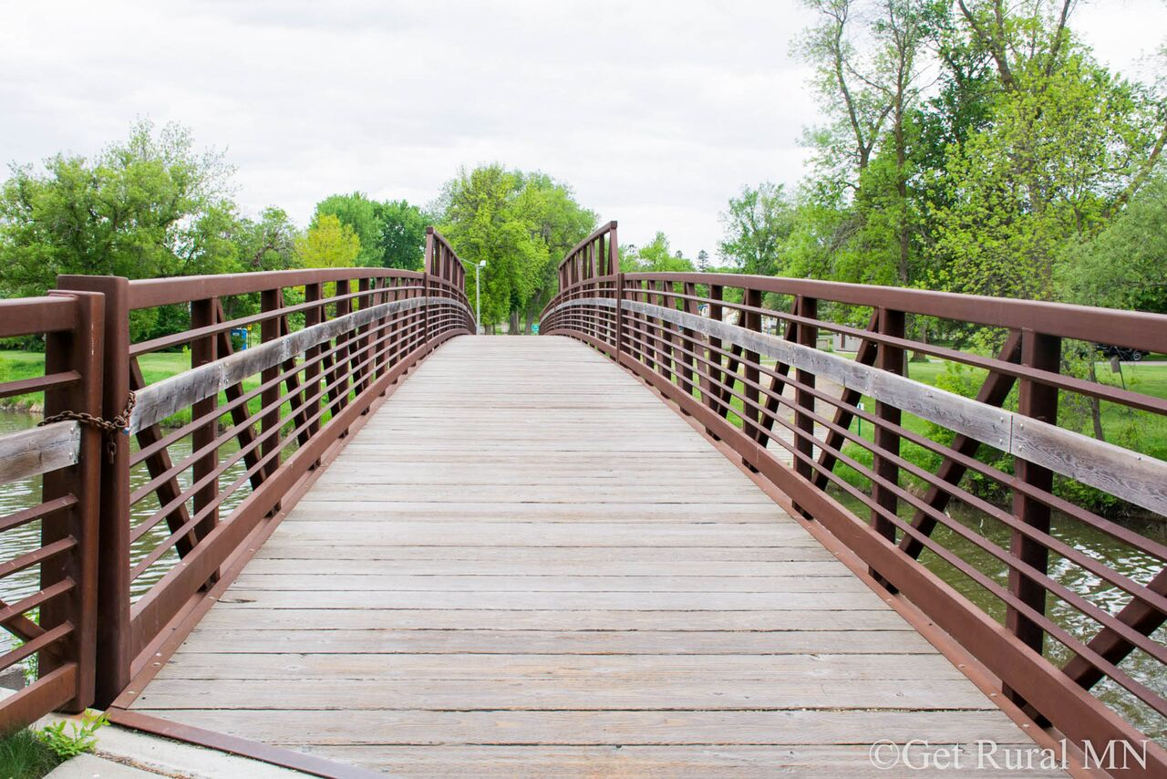

Broadband in Lac qui Parle County

323 W Schlieman Ave. Appleton, MN 56208 || 320.289.1981 || www.umvrdc.org