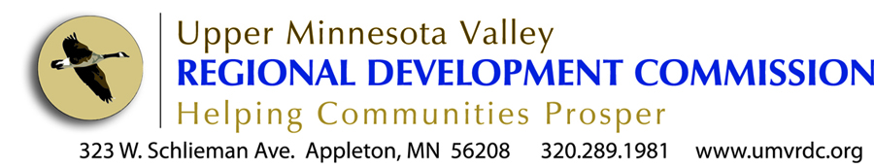

The UMVRDC wants to help cities in our region. For us, it is as simple as following our mission statement that directs us to “enable the region to thrive by assisting units of government”. We know through our recent city survey that cities have lots of needs but are having a hard time paying for them. We listened to you and created a fund to help subsidize the cost of our services to assist you with your requests.

Local Assistance Fund

Eligibility
- Eligible entities for the Local Assistance Fund include local units of government (cities, counties, townships, tribes and school districts) located in Big Stone, Chippewa, Lac qui Parle, Swift and Yellow Medicine Counties.
- $10,000 is earmarked for cities under 500 in population.
- $10,000 is available to all local units of government in our region.
- Funds are available for UMVRDC services in the areas of comprehensive planning, strategic planning and grant writing.
- Eligible entities may apply for a 50% reduction in the costs for UMVRDC services up to a maximum of $4,000.
- One grant per project.
- One grant per eligible entity per year.
- Local Assistance Funds are valid upon signed contract with the UMVRDC for services and will be shown as a discount on the final billing for the work outlined in the contract.
- Funds will be made available annually at the discretion of the UMVRDC.
- The UMVRDC reserves to right to update the eligibility guidelines at any time.

Nature of Project
What type of project are you interested in?
____ Comprehensive Planning Strategic Planning ___ Grant Writing

Contact Information
Community Name
Contact Person
Mailing Address
City/ State/ZIP
Work Phone
Alt. Phone
E-Mail Address

Project Details

Please provide a brief description of the project you would like assistance with: _______________
__________________________________________________________________
__________________________________________________________________
___________________________________________________________________________________________________________________

Estimated Project Cost
Total Estimated Project Cost $___________
Requested Amount from Local Assistance Fund $___________
(Maximum request: eligible entities may apply for 50% of the total project cost up to $4,000.)

Are the remaining project costs committed from the City or other entity? ____ Yes ____ No

(If Applicable) Please list any other partners in the project and their financial commitment:
Organization & Contact Committed Amount
_____________________________________ _________________
_____________________________________ _________________

Authorized Signature

______________________________ _____________________
Authorized Signature Date

________________________________
Authorized Signature Title

Thank you for completing this application and
your interest in working with the UMVRDC!

